***Task 10.3HD: Implementing a Serverless Architecture for the Cafe (SIT 233)***

Submission details :-

---> The outputs of each sections/sub-tasks as screenshots with some text descriptions to demonstrate that you have successfully completed the task.

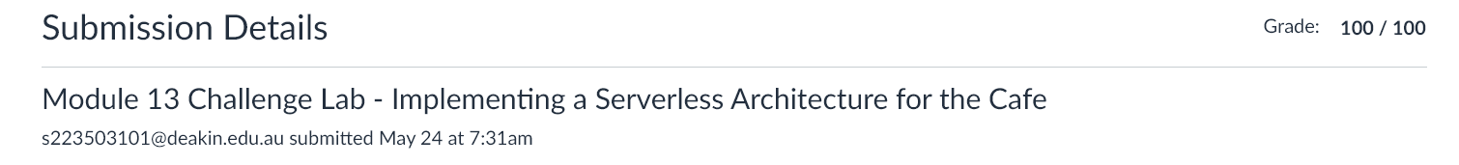

…. Completed the Implementing a Serverless Architecture for the Cafe Lab exercise….

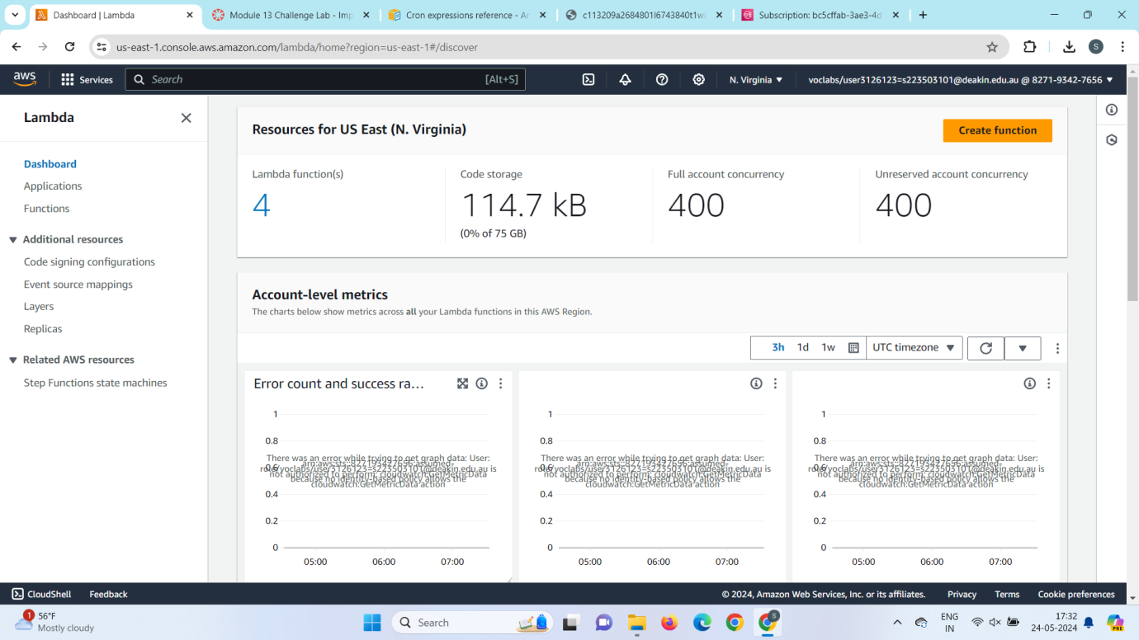

1. **AWS Lambda:**

* **Serverless compute service by AWS.**
* **Runs code in response to events without managing servers.**
* **Supports multiple programming languages.**
* **Scales automatically and charges only for the compute time consumed.**

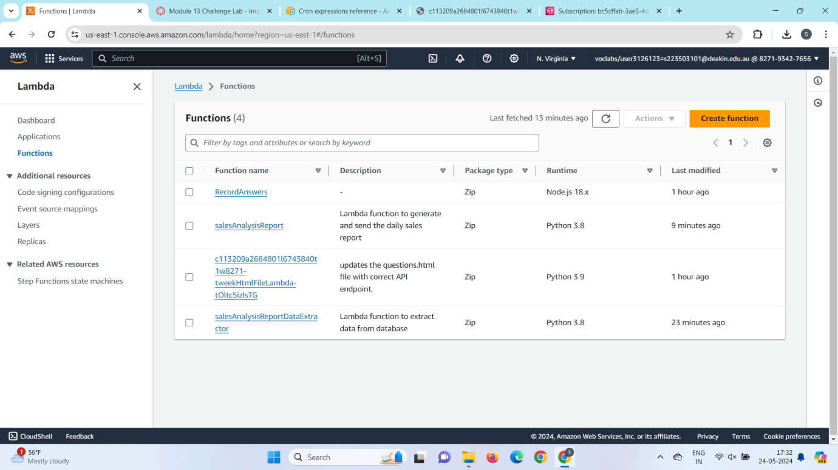

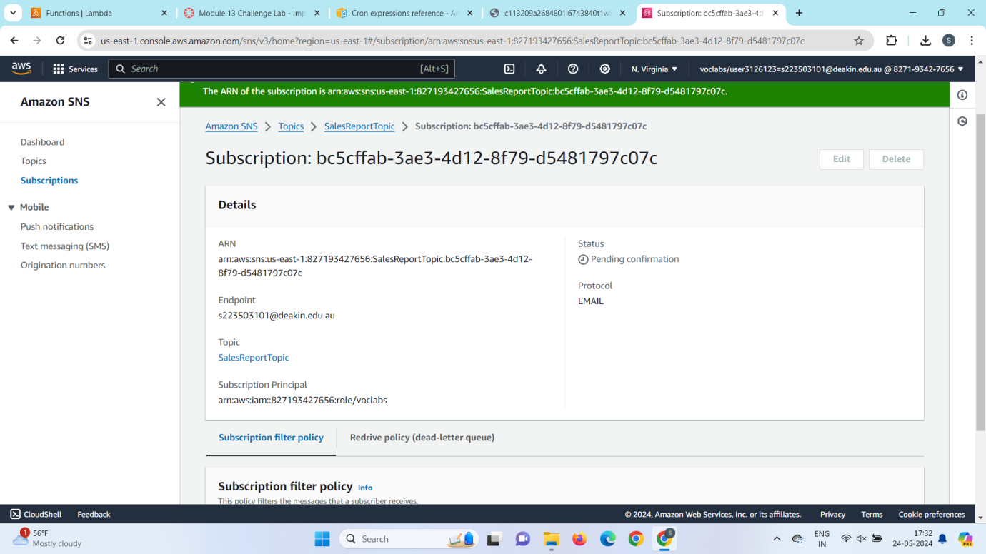

1. **Amazon Simple Notification Service (SNS)**:

* **Fully managed pub/sub messaging service.**
* **Enables publishing messages to topics and delivering them to subscribers.**
* **Supports various protocols for message delivery.**
* **Highly scalable and reliable.**

1. **Subscription**:

* **In SNS, a link between a topic and an endpoint (such as an email, SMS, Lambda function, etc.).**
* **Subscribers receive messages published to the topic.**
* **Types of subscriptions include HTTP/HTTPS, Email, SMS, Lambda, etc.**
* **Subscribers must confirm their subscription to start receiving messages.**

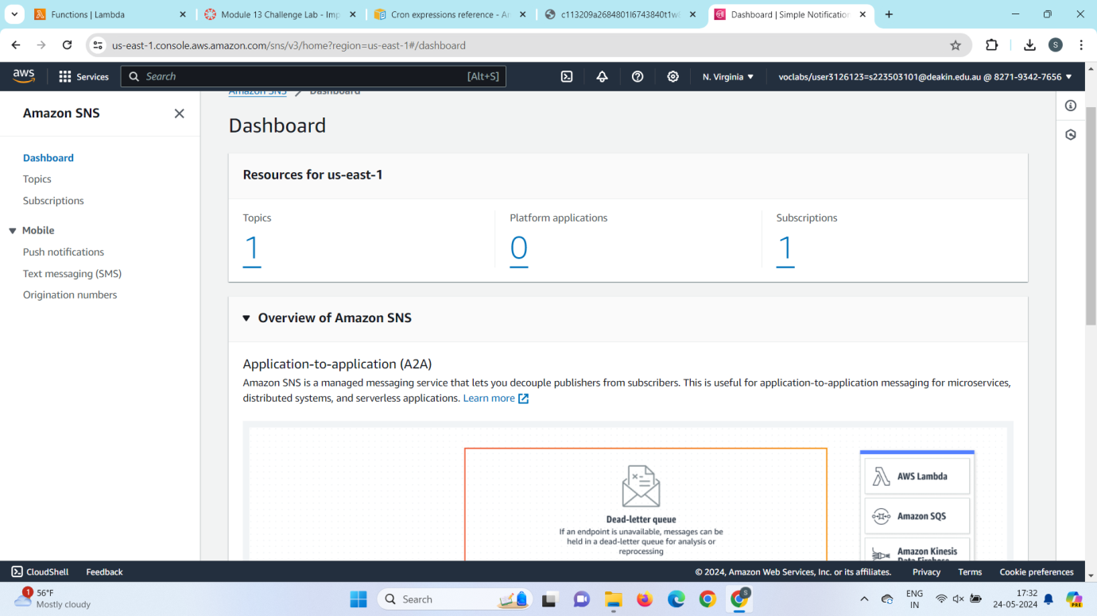

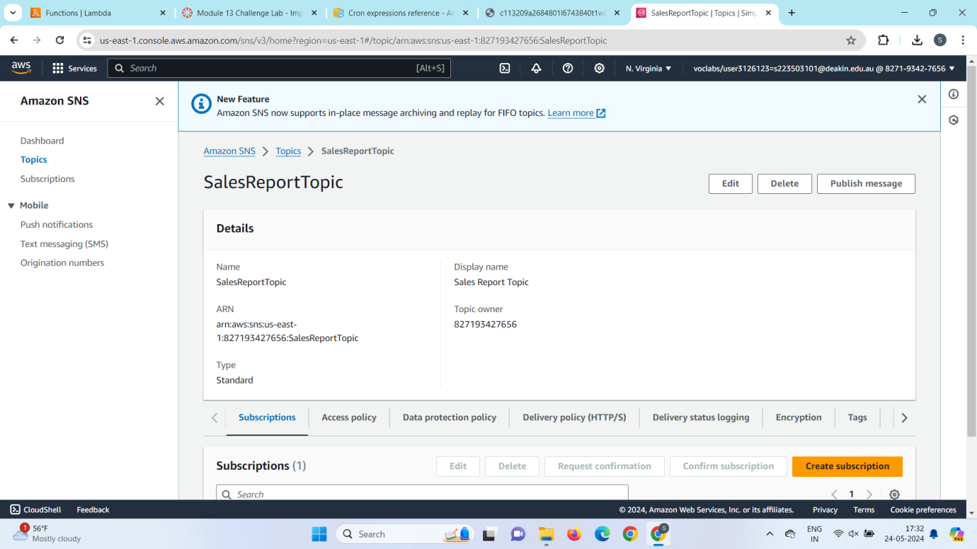

---> Task Questions

1. Why does the salesAnalysisReportDataExtractor.zip file have a package folder?

[Answer 01] Correct. The package folder is used to store any packages used by your script.

1. Why must the salesAnalysisReportDataExtractor Lambda function be in a VPC?

[Answer 02] Correct. The lambda needs to be able to communicate with the RDS instance.

1. Could the topicARN be stored as an AWS Systems Manager parameter instead of as an environment variable (assuming that the code could be updated)?

[Answer 03] Correct. You could store the topicARN in SSM.

1. Will you receive an email message if you do not confirm the topic subscription?

[Answer 04] Correct. You need to accept subscriptions before messages are delivered.

1. Frank tells you that he hasn't received an email report in the last few days. What could you do to troubleshoot this issue?

[Answer 05] Correct. You can use the logs in cloudwatch to look for errors.

---> Screenshots to demonstrate you have successfully completed the Knowledge Check.

